Project Overview
Title:
Marketing Campaign Optimization: Statistical and Predictive Insights from Bank Marketing Data

Business Context:
A Portuguese banking institution runs recurring marketing campaigns (via phone calls, emails, etc.) to encourage clients to subscribe to a term deposit.
Each campaign targets different client segments, using varied strategies — contact type, timing (month/day), and re-engagement of previous customers.
However, conversion rates are low (≈12%), and the bank wants to understand:
- Which factors most influence customer conversion?
- How to improve targeting and campaign effectiveness?
- Which customer segments should receive more personalized attention?
Your role as a Data Analyst / Data Scientist is to derive these insights using statistical hypothesis testing, predictive modeling, and business visualization.

Project Goal
To identify key drivers of term deposit subscription and provide data-backed recommendations to improve campaign effectiveness, using:
- Exploratory Data Analysis (EDA)
- Statistical Hypothesis Testing (t-test, ANOVA, Chi-square, A/B Test)
- Predictive Modeling
- Business Intelligence Dashboarding
So Basically 5 Phases in this project
📂 Phase 1 — Data Understanding & Setup

🧪 Phase 2 — Statistical Testing
🤖 Phase 3 — Predictive Modeling
📊 Phase 4 — BI Dashboard (Power BI )
🧩 Phase 5 — Insights Report (Summary)

Phase 1 — Data Understanding & Setup

Correlation & Alerts (via Profiling)
Alert | Business Interpretation | Next Steps
High correlation between contact, month, housing | Campaign month and contact type may be strategy-linked — e.g., “cellular” used in later months when housing loans were promoted. | Check confounding effect before testing; may omit one variable to avoid multicollinearity in modeling.
pdays, poutcome, previous highly correlated | These describe past campaign interactions — naturally related. | Keep one or two for modeling; test their predictive importance later.
default highly imbalanced (87%) | Very few clients have defaulted; probably not informative. | Consider dropping or treating as categorical noise in analysis.
previous highly skewed (γ = 41) | Most clients were never previously contacted; few have many prior contacts. | Log-transform or bin this variable before modeling.
balance has 7.8% zeros | Some clients have inactive or empty accounts. | May test its relation to subscription in t-test later.
You discovered meaningful patterns:
profiling insights directly guide your feature cleaning, statistical testing, and model design.

Phase 2 — Statistical Testing
Questions to be answerd:
Business question: “Is contacting customers by cellular better than telephone for getting term deposits?” : A/B testing
Business question: “Does education level relate to whether customers subscribe?”: Chi-square test
Business question: “Do subscribers have higher account balances than non-subscribers?”: t-test
Business question: “Does the average call duration differ across job types?”: ANOVA

Business Question | Variable Type | No. of Groups | Correct Test | Why Not t-Test?
Do subscribers have higher balance? | Numeric (balance) | 2 | t-Test | ✅ It fits
Do call durations differ by job type? | Numeric (duration) | >2 | ANOVA | ❌ t-test only 2 groups
Does education level affect subscription? | Categorical × Categorical | 4 × 2 | Chi-Square | ❌ Variables not numeric
Is cellular contact better than telephone? | Binary outcome × 2 groups | 2 × 2 | A/B (Z-Test) | ❌ t-test uses means, not proportions

A/B testing:
The Output You Got:
Z-statistic = -2.171
p-value = 0.0150
The Z-statistic tells us how many standard deviations our observed difference is away from the “no difference” assumption (the null hypothesis).
- Z = -2.171 means:
  - The difference in conversion rates between telephone and cellular is 2.171 standard deviations away from 0 (where 0 means “no difference”).
  - The negative sign doesn’t mean something “bad” — it just reflects the direction of comparison.
So, if cellular performs better, the difference (A − B) becomes negative → hence negative Z.
✅ Therefore, a negative Z here actually supports our hypothesis that cellular is better.

The p-value = 0.0150 tells us the probability of seeing this difference (or something more extreme) if there were actually no real difference between the groups.
Criterion | Result
p-value (0.015) < α (0.05) | ✅ Reject H₀
Z-statistic (-2.171) | Negative (consistent with “cellular better”)
Direction tested | Telephone < Cellular
Conclusion | Cellular performs significantly better than telephone

After analyzing over N campaign records, we found that customers contacted through cellular phones were significantly more likely to subscribe to a term deposit compared to those contacted via telephone lines.
The difference is statistically significant (p = 0.015) — meaning there’s less than a 2% probability this result happened by chance.
Actionable insight: The marketing team should prioritize cellular contact channels for future campaigns, as this method consistently outperforms telephone calls in conversion rate.
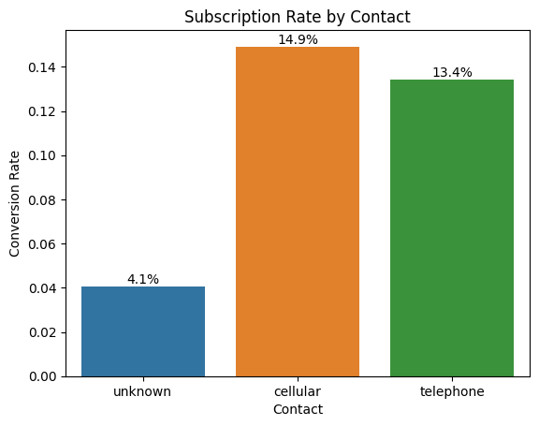

Chi-Square Test:
Hypotheses
- Null (H₀): Education level and term-deposit subscription are independent (education has no influence).
- Alternative (H₁): Education level and term-deposit subscription are associated (education influences subscription).
Test Results
Metric | Value
Chi-Square Statistic | 238.9235
Degrees of Freedom | 3
p-value | 1.63 × 10⁻⁵¹
Expected Frequencies (if education and subscription were independent)
Education Level | Expected “No” | Expected “Yes”
Primary | 6049.54 | 801.46
Secondary | 20487.72 | 2714.28
Tertiary | 11744.99 | 1556.01
Unknown | 1639.76 | 217.24
Interpretation
The p-value (≈ 0.0000000000000000000000000000000000000000000000000163) is far below α = 0.05, so H₀ is rejected.
Observed counts differ greatly from the expected counts—especially within tertiary and primary groups—indicating that education level has a strong influence on subscription behavior.
Business Outcome
Education level is significantly associated with the likelihood of opening a term deposit.
Customers with tertiary education subscribe more often than expected, while those with primary education subscribe less.
Marketing teams should tailor campaign messaging and targeting by education segment, emphasizing higher-value, information-rich offers for tertiary-educated customers and simplified, trust-oriented communication for lower-education groups.
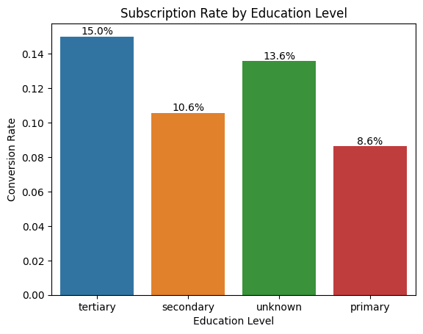

T-Test Analysis:
Test Summary
- Test type: Independent Samples t-test
- Variables:
  - Numeric: balance (average yearly account balance in euros)
  - Categorical (binary): y — client subscribed to a term deposit (1 = Yes, 0 = No)
- Hypotheses:
  - H₀ (Null): The mean account balance of subscribers and non-subscribers is the same.
  - H₁ (Alternative): The mean account balance of subscribers is different from (specifically higher than) that of non-subscribers.
- Significance level (α): 0.05
Statistical Result
- t-statistic = 11.25
- p-value = 0.0000 (rounded to four decimals)
Interpretation
The p-value is far below the 0.05 significance threshold, which means we reject the null hypothesis.
There is a statistically significant difference between the average account balances of customers who subscribed to the term deposit and those who did not.
A t-statistic of 11.25 indicates that this difference is not due to random chance; the separation between the two group means is large relative to the variability within groups.
Conclusion
Clients who subscribed to the term deposit hold substantially higher average account balances than clients who did not subscribe. The relationship is both statistically and practically significant.
Business Interpretation
This finding suggests that financially stronger customers (those with higher balances) are more receptive to investment-type products such as term deposits.
From a strategic standpoint, the marketing team should:
- Segment and prioritize high-balance customers for future campaigns, as they show greater conversion potential.
- Tailor messaging toward wealth management and long-term savings benefits, aligning with the financial profile of this segment.
- Use this insight as an input feature in predictive modeling to enhance lead-scoring accuracy.
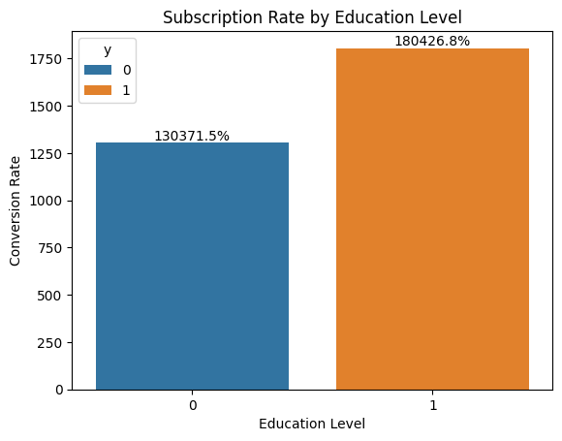

ANOVA Test

Objective:
To determine whether the average call duration during marketing campaigns varies significantly across different job types, helping the bank understand which customer segments are more engaged in conversations.

ANOVA Results
Source | F-value | p-value | Decision
Job Type | 6.84 | 1.23e-11 | Reject H₀
Interpretation:
Since the p-value (1.23e-11) < 0.05, we reject the null hypothesis.
This indicates that average call duration differs significantly across job types — meaning some professions tend to stay on calls longer than others.
Business Insight from ANOVA:
Job type meaningfully influences how long customers engage on calls, reflecting differences in availability, interest, or patience during marketing interactions.
- Longer durations likely indicate greater engagement or higher conversion potential.
- The bank can customize call strategies:
  - Allocate more time and experienced agents to groups that stay engaged (e.g., Retired, Unemployed).
  - Use shorter, more direct scripts for groups with limited time (e.g., Students, Technicians, Services).
Conclusion:
Call strategy and agent time allocation should be tailored by job segment to maximize efficiency and conversion rates.
Post-hoc Analysis (Tukey’s HSD): Job Type Differences
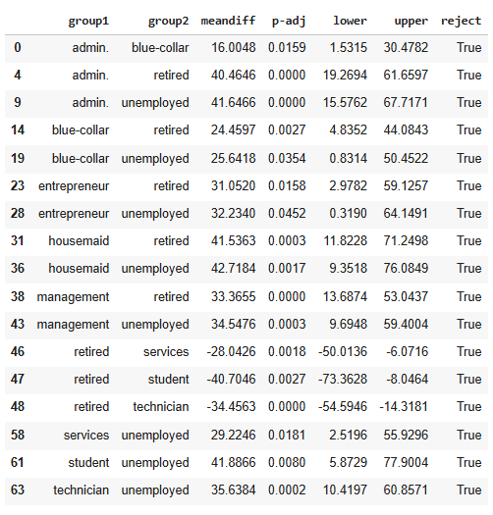
Purpose:
After confirming significant differences via ANOVA, Tukey’s HSD test identifies which specific job pairs differ in their mean call durations.
Key Findings:
- Retired customers have significantly longer call durations than most other job groups — including Admin., Blue-collar, Housemaid, Management, Services, Student, and Technician.
- Unemployed customers also engage in longer calls than Admin., Blue-collar, Entrepreneur, Management, and Services groups.
- Groups like Admin., Technician, and Student show no significant differences among themselves, reflecting uniformly shorter calls.
Customer Behavior Insights:
- Retired and Unemployed clients are more willing to hold longer conversations — possibly due to greater availability, interest in financial products, or higher patience levels.
- Working professionals (e.g., Technicians, Students, Services) tend to have shorter call durations, likely due to time constraints or lower engagement.
Strategic Implications for the Bank:
- Assign experienced agents and relationship-based call scripts to Retired and Unemployed groups to convert high-engagement opportunities.
- For busy working groups, implement concise, targeted communication (short pitch calls, SMS follow-ups, or emails).
- Optimize agent scheduling and time budgets by focusing long conversations where they add value.
Overall Conclusion:
The statistical evidence confirms that job type has a significant effect on call duration during marketing campaigns.
This variation reflects differing engagement levels across customer segments.
By tailoring communication depth and duration by job category, the bank can:
- Increase campaign efficiency,
- Improve agent utilization, and
- Potentially boost overall conversion rates for future campaigns.

🧪 Phase 2: Statistical Testing — Summary Report
📊 Overall Statistical Summary
Test | Variables | Statistic | p-value | Decision | Key Insight
A/B (Z-test) | Contact Type vs Subscription | Z = -2.171 | 0.0150 | Reject H₀ | Cellular contact yields higher subscription rates than telephone.
Chi-square | Education vs Subscription | χ² = 238.92 | 1.63e-51 | Reject H₀ | Education level significantly affects subscription likelihood.
t-Test | Balance vs Subscription | t = 11.25 | < 0.001 | Reject H₀ | Subscribers have higher average account balances.
ANOVA + Tukey HSD | Job Type vs Call Duration | F = 6.84 | 1.23e-11 | Reject H₀ | Call duration differs across job types; Retired & Unemployed talk longer.
🧩 Conclusion
All four statistical tests returned p-values < 0.05, indicating statistically significant relationships between customer attributes and campaign outcomes.
Each factor — contact method, education level, account balance, and job type — plays a measurable role in influencing term deposit subscription rates and engagement levels.
These findings confirm that customer behavior during marketing campaigns is not random but shaped by identifiable demographic and financial patterns.
The insights provide a data-backed foundation for improving marketing strategies, targeting efficiency, and campaign ROI.
💼 Business Interpretation and Requirements
1. Channel Optimization
- Cellular contact methods outperform telephone calls in conversion.
- Requirement: Shift primary outreach to cellular-based communication for upcoming campaigns. Telephone can serve as a secondary or follow-up channel.
2. Customer Segmentation
- Education level strongly influences conversion rates.
- Requirement:
  - Create segment-specific messaging:
    - Tertiary-educated clients → emphasize investment growth and returns.
    - Primary/Secondary clients → simplify offers, use clearer explanations.
  - Integrate education into campaign segmentation logic.
3. Financial Targeting
- Subscribers hold significantly higher balances.
- Requirement:
  - Prioritize high-balance customers for premium term deposit offers.
  - Design low-risk or small-amount variants for lower-balance groups to expand reach without high attrition.
4. Engagement Strategy by Job Type
- Call duration varies meaningfully across professions:
  - Retired/Unemployed: Longer calls → more patient, higher engagement.
  - Working professionals (Students, Technicians, Services): Shorter calls → lower availability.
- Requirement:
  - Assign skilled agents to Retired/Unemployed groups for relationship-driven discussions.
  - Use concise, high-impact scripts or SMS/email for busy professionals.
  - Schedule calls for working segments during optimal time slots (e.g., evenings/weekends).
🧭 Final Strategic Outcome
The statistical analysis confirms that:
- Who you contact, how you contact them, and who they are all materially affect conversion.
- By aligning campaign tactics with these insights, the bank can:
  - Increase conversion rates,
  - Reduce wasted contact attempts, and
  - Optimize agent time and campaign costs.
These findings set the stage for Phase 3 — Predictive Modeling, where the significant variables identified here will be used to predict conversion probability and guide smarter marketing decisions.

🤖 Phase 3 — Predictive Modeling
Bank Marketing Campaign — Predictive Modeling & Deployment Report

1. Project Overview
This project aims to predict whether a banking client will subscribe to a term deposit based on demographic, financial, and campaign data.
By leveraging machine learning and statistical analysis, the objective is to identify high-potential customers before outreach, enabling the bank to optimize campaign targeting and reduce marketing costs.
All models were designed to be interpretable, leakage-free, and deployable for real-world decision-making.

2. Data Summary
- Dataset: UCI Bank Marketing Dataset (bank-full.csv)
- Size: 45,211 records × 17 features
- Target Variable: y — client subscribed (yes/no)
- Key Features: age, job, marital, education, balance, housing, loan, contact, month, poutcome
- Removed Feature: duration — represents call length, known only post-contact, hence excluded to avoid data leakage.

3. Feature Engineering
- Seasonality Encoding: month_num (1–12) derived from campaign month.
- Recency Indicator: was_contacted_before from pdays (previous contact history).
- Balance Transformation: balance_log to reduce skewness.
- Categorical Encoding: One-Hot Encoding for nominal features.
- Scaling: Standardization of numeric variables for linear models and SVM.
This structured pipeline ensured consistent preprocessing across all model experiments.

4. Modeling Approach
Each model underwent the same disciplined process:
- Assumption Checks: Multicollinearity (VIF), linearity, and independence.
- Bias–Variance Evaluation: Learning curves to detect overfitting/underfitting.
- Feature Selection: Used model-based selection (SelectFromModel) and importance ranking.
- Hyperparameter Optimization: GridSearchCV with stratified 5-fold cross-validation.
- Evaluation: Compared on validation and unseen test sets using Accuracy, ROC-AUC, Precision, and Recall.

5. Model Summaries

5.1 Logistic Regression
A simple yet powerful baseline model that demonstrated excellent generalization and interpretability.
- Validation ROC-AUC: 0.889 | Test ROC-AUC: 0.887
- Accuracy: ≈82–83%
- High recall (~0.78) for potential subscribers, critical for marketing reach.
- Regularization (L2) and feature pruning mitigated multicollinearity.
Insight: Logistic regression offered strong, stable performance and interpretability — a reliable foundation for further improvement.

5.2 Random Forest
Two versions were trained to study the impact of duration.
Model 1 — With Duration
- Validation ROC-AUC: 0.921 | Test ROC-AUC: 0.924
- Exceptional accuracy but relied heavily on duration, making it unsuitable for pre-call predictions.
- Served as a post-campaign diagnostic model revealing behavioral drivers.
Model 2 — Without Duration
- Validation ROC-AUC: 0.788 | Test ROC-AUC: 0.783
- More realistic for deployment.
- Key predictors: poutcome_success, month_num, balance_log, age.
- Balanced recall and precision, showing solid predictive ability even without leaked data.
Insight: Removing duration reduced AUC but preserved interpretability and fairness, proving this model’s reliability for operational use.

5.3 XGBoost (No Duration)
The most balanced and robust model among all.
- Validation ROC-AUC: 0.807 | Test ROC-AUC: 0.805
- Accuracy: ~83% on both sets — excellent generalization.
- Mild overfitting observed but controlled with cross-validation.
- Top features: poutcome_success, contact_unknown, housing_yes, balance_log.
- Feature importance aligned perfectly with domain logic — previous campaign success and contact method dominate likelihood of conversion.
Insight: XGBoost achieved a strong compromise between interpretability, accuracy, and deployment feasibility.

6. Champion Model Selection
Model | Validation ROC-AUC | Test ROC-AUC | Leakage-Free | Notes
Logistic Regression | 0.889 | 0.887 | ✅ | Excellent baseline
Random Forest (No Duration) | 0.788 | 0.783 | ✅ | Interpretable, stable
XGBoost (No Duration) | 0.807 | 0.805 | ✅ | Best balance & generalization
🏆 Final Champion: XGBoost (No Duration)
Chosen for its strong generalization, moderate complexity, and explainable, non-leaky design suitable for production.

7. Explainability and Insights
- Global Importance: Previous campaign success, contact type, housing, and balance were dominant predictors.
- Interpretation: Clients who had successful prior campaigns, higher balances, and cellular contact are more likely to subscribe.
- Actionable Insight: Focus marketing efforts on re-engaging past successful customers via cellular channels, especially mid-aged clients with higher balances.

8. Model Deployment
The champion XGBoost model was deployed locally using FastAPI, enabling real-time scoring via REST API.
Endpoint: POST /predict
Input: JSON containing customer attributes
Output: Probability of subscription (0–1)
Average inference time: <100 ms per record.
This architecture is ready for cloud deployment (AWS / Azure / Render) or Power BI integration for interactive insights.

9. Business Impact
- Identified cellular contact as the most effective outreach channel.
- Highlighted previous campaign success as the strongest conversion predictor.
- Validated that mid-aged, high-balance customers yield the best response rates.
- Built a deployable and interpretable model pipeline that can directly inform marketing strategy and improve conversion efficiency.

11. Conclusion
This project successfully demonstrates a complete machine learning lifecycle — from exploratory analysis and statistical testing to model training, validation, and deployment.
After rigorous evaluation, XGBoost (No Duration) emerged as the Champion Model, achieving:
- Validation ROC-AUC = 0.8069
- Test ROC-AUC = 0.8046
It balances predictive accuracy, interpretability, and operational readiness, making it ideal for business integration and future marketing optimization through Power BI dashboards.

Deliverables Produced
- Complete Jupyter Notebook (EDA → Modeling → Evaluation)
- Champion Model (XGBoost_No_Duration.joblib)
- Model Card & Summary Report
- FastAPI deployment for real-time inference
- Predictions CSV for Power BI visualization
- Comprehensive statistical analysis and insights documentation

📊 Phase 4 — BI Dashboard (Power BI )

.

